**Assignment 1:** Draw your Home Network Topology and explain how you are accessing the RPS Lab environment.

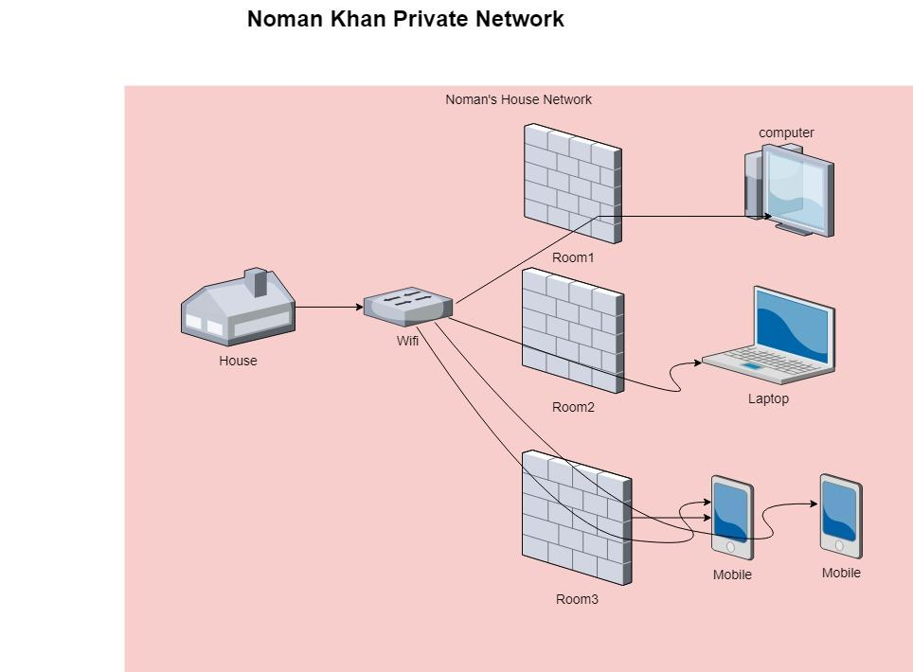

In the above diagram, there is a House which have 1 Wifi Network

And there are 3 rooms(room1, room2, room3) in the room 1 there is one computer which is connected to the wifi router. And in the room 2 there is one laptop which is also connected to the same wifi router. And in the room 3 there are 2 mobiles which are also connected to wifi router. And all the devices are connected to same router and accessing the Internet. Its create one Private Network together.

**Assignment 2:** Identify a real-world application for both parallel computing and networked systems. Explain how these technologies are used and why they are important in that context.

**Parallel Computing**: Climate patterns are often examples of highly complicated phenomena like complex phenomena. In such projects, there is a need to deal with large amounts of data that need to be processed and analyzed in parallel so as to make sense out of such things. Because these datasets are very bulky, parallel computing makes it possible to break them down into smaller pieces or chunks which can be processed simultaneously on multiple computing nodes or cores. Thus, each node or core operates independently on a fraction of the data thereby reducing significantly the time taken for analysis.

**Networked Systems:** Networked systems have an important role to play in coordinating the distributed computing resources used in these projects. High-speed networks connect computing clusters or supercomputers spread across different locations, enabling seamless communication and data exchange between nodes. This network infrastructure allows researchers to access and share data, distribute computing tasks efficiently, and collaborate with colleagues located anywhere in the world.

**Importance**:

**Scalability**: Parallel computing paradigms and networked systems enable scientists involved in this kind of analysis to scale their computational resources accordingly; thus they are able to handle more complex computational tasks as well as larger datasets recently.

The computational resources of analysts can be ramped up and down as they may need them by parallel computing and networked systems. Moreover, these technologies help researchers to tap into the collective power of several machines, which is useful in processing vast datasets or complex loads.

**Efficiency**: Parallel computing has been found to reduce the time required for analyzing large datasets’ by sharing data-processing tasks among a number of nodes. This heightened efficiency is crucial for time-bound studies like weather prediction and impact assessment due to climate change.

**Collaboration**: For example, by enabling access to shared data and computer services, research networks foster collaborations between scholars despite their locations. They engage in analysis that real-time contributes insights.

**Resilience**: Centralised systems are more prone to failure than distributed ones such as those based on distributed computing architecture. Thus any node (CPU) breaks or malfunctions; the load will be automatically re-distributed among other nodes.

**Cost-Effectiveness**: These organizations can therefore exploit their computing resources optimally using parallel computation and network systems.